**REG.No: ……………………………………….**

**MODULE: AUTOMATION CONTROL SYSTEM MODULE CODE: REN302**

**Assessment/ Thursday 26th Aug, 2021**

1. Select the device (PLC, sensor, actuator, transducer, relay) that is described in the following points.
2. It converts the electrical energy into any other form of energy:…………….
3. It converts any environmental physical change into electrical signal:………….
4. It converts one form of energy into another:………………….
5. It converts an electrical signal into a mechanical energy:………………..
6. A system that can allow the operators to employ the PLC to monitor and control a large system at remote locations is called……………………………………
7. PLC System b) SCADA system c) Control system d) Automation system
8. The basic function of a control system is……………………
9. To minimize the error between the actual response and desired output
10. To minimize the time response to load changes in the system
11. To make sure that the system output is controlled
12. To increase the quality of the system production
13. Is the ladder logic in the figure below for an AND or an OR gate?..............................

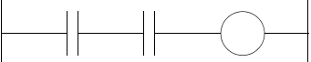

1. The term PLC stands for …………………………………….
2. Personal logic computer b) Programmable local computer c) Personal logic controller

d)Programmable logic computer e) Programmable logical controller

1. A component of a PLC that reads the inputs and updates the outputs based on the instructions given in ladder diagram is called………....................................
2. Programming unit b) memory b) CPU c) memory d) input and output module

7) The layer of industrial control and automation that performs machines control modes failure detection, redesign of control loops and gives graphical user interface is called----------------

a) Sensing and Actuation Elements b) Industrial Control Systems c) Supervisory Control

d) Production Control e) Enterprise

8) Provide the truth table of the following PLC Ladder Diagram.

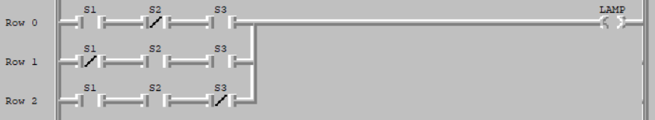

THANK YOU!!!!!

**Truth Table**

|  |  |  |  |
| --- | --- | --- | --- |
| S1 | S2 | S3 | **Lamp** |
| 0 | 0 | 0 |  |
| 0 | 0 | 1 |  |
| 0 | 1 | 0 |  |
| 0 | 1 | 1 |  |
| 1 | 0 | 0 |  |
| 1 | 0 | 1 |  |
| 1 | 1 | 0 |  |
| 1 | 1 | 1 |  |